## PRACTICAL TEN: CORRELATION AND REGRESSION WITH SPSS

1. Generate a multivariate problem and corresponding data.
2. Give a step by step procedure to obtain the pair-wise covariance and correlation of the variables with SPSS.
3. Run the analysis in (b) above.
4. Give a step by step procedure for (i) simple and (ii) multiple regression analysis with SPSS.
5. Run the analysis in (d) above and write the regression models from the outputs.

SOLUTION

The grade and CGPA of students in the department of statistics with respect to their Matric Number

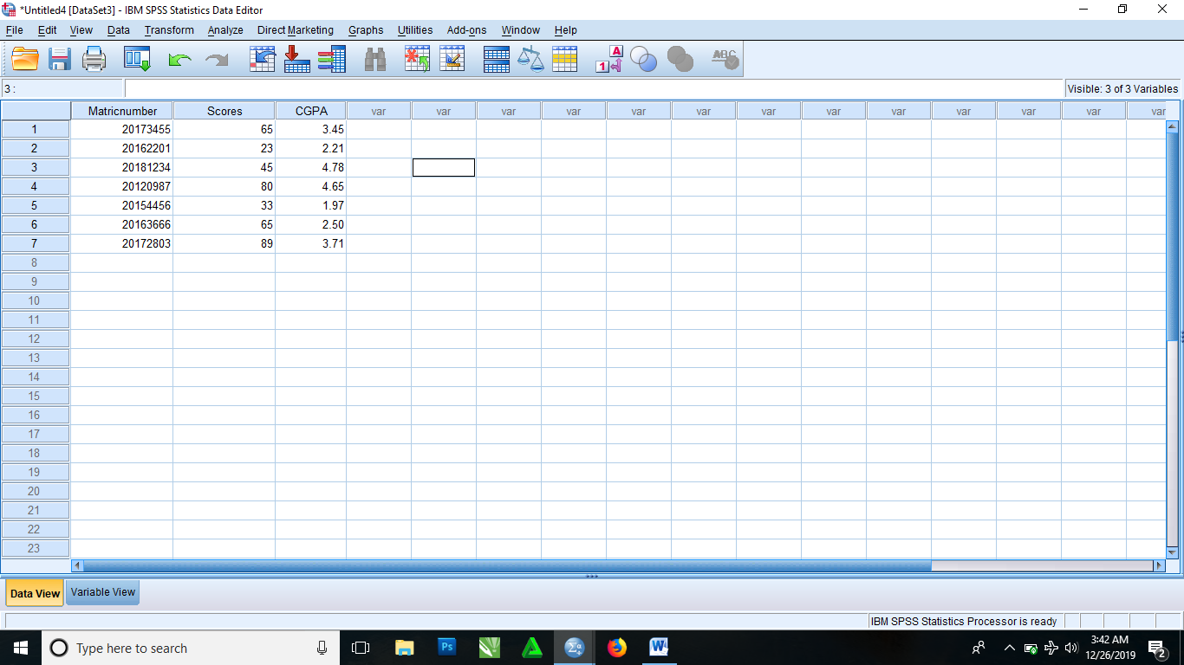

* Input the data into the SPSS and do the necessary editing in the variable view

From the menus, click

* Analyze > Correlate > Bivariate
* It then brings you to a Bivariate Correlations dialog box where you click and drag variables from the left box to the variables box and you drop
* Click Option
* It then brings you to a dialog box. Then you select Cross-product deviations and covariances in the statistics box and select Exclude cases pairwise in the missing values box.
* Click Continue
* Click OK.

|  |  |  |  |  |
| --- | --- | --- | --- | --- |
| **Correlations** | | | | |
|  | | Matric number | Scores | CGPA |
| Matric number | Pearson Correlation | 1 | -.189 | -.090 |
| Sig. (2-tailed) |  | .684 | .848 |
| Sum of Squares and Cross-products | 2355802765.714 | -548478.429 | -12145.883 |
| Covariance | 392633794.286 | -91413.071 | -2024.314 |
| N | 7 | 7 | 7 |
| Scores | Pearson Correlation | -.189 | 1 | .541 |
| Sig. (2-tailed) | .684 |  | .209 |
| Sum of Squares and Cross-products | -548478.429 | 3556.857 | 90.166 |
| Covariance | -91413.071 | 592.810 | 15.028 |
| N | 7 | 7 | 7 |
| CGPA | Pearson Correlation | -.090 | .541 | 1 |
| Sig. (2-tailed) | .848 | .209 |  |
| Sum of Squares and Cross-products | -12145.883 | 90.166 | 7.796 |
| Covariance | -2024.314 | 15.028 | 1.299 |
| N | 7 | 7 | 7 |

To get the simple regression of the above data, you follow the following procedure

* From the menus, select

Analyze > Regression > Linear

* It then brings you to a dialog box. From the list of variables in the left box, you click and drag the variable Matric number and drop it in the Independent(s) box and click and drag CGPA and drop it in the Dependent box
* Click OK

|  |  |  |  |
| --- | --- | --- | --- |
| **Variables Entered/Removeda** | | | |
| Model | Variables Entered | Variables Removed | Method |
| 1 | Matric numberb | . | Enter |
| a. Dependent Variable: CGPA | | | |
| b. All requested variables entered. | | | |

|  |  |  |  |  |
| --- | --- | --- | --- | --- |
| **Model Summary** | | | | |
| Model | R | R Square | Adjusted R Square | Std. Error of the Estimate |
| 1 | .090a | .008 | -.190 | 1.24368 |
| a. Predictors: (Constant), Matric number | | | | |

|  |  |  |  |  |  |  |
| --- | --- | --- | --- | --- | --- | --- |
| **ANOVAa** | | | | | | |
| Model | | Sum of Squares | df | Mean Square | F | Sig. |
| 1 | Regression | .063 | 1 | .063 | .040 | .848b |
| Residual | 7.734 | 5 | 1.547 |  |  |
| Total | 7.796 | 6 |  |  |  |
| a. Dependent Variable: CGPA | | | | | | |
| b. Predictors: (Constant), Matric number | | | | | | |

|  |  |  |  |  |  |  |
| --- | --- | --- | --- | --- | --- | --- |
| **Coefficientsa** | | | | | | |
| Model | | Unstandardized Coefficients | | Standardized Coefficients | t | Sig. |
| B | Std. Error | Beta |
| 1 | (Constant) | 107.270 | 516.605 |  | .208 | .844 |
| Matric number | -5.156E-006 | .000 | -.090 | -.201 | .848 |
| a. Dependent Variable: CGPA | | | | | | |

To get the multiple regression analyses, you follow the following procedures

* From the menus, select

Analyze > Regression > Linear

* It then brings you to a dialog box. From the list of variables in the left box, you click and drag the variables CGPA and Scores and drop it in the Independent(s) box and click and drag Matric number and drop it in the Dependent box
* Click OK

|  |  |  |  |
| --- | --- | --- | --- |
| **Variables Entered/Removeda** | | | |
| Model | Variables Entered | Variables Removed | Method |
| 1 | CGPA, Scoresb | . | Enter |
| a. Dependent Variable: Matric number | | | |
| b. All requested variables entered. | | | |

|  |  |  |  |
| --- | --- | --- | --- |
| **Variables Entered/Removeda** | | | |
| Model | Variables Entered | Variables Removed | Method |
| 1 | CGPA, Scoresb | . | Enter |
| a. Dependent Variable: Matric number | | | |
| b. All requested variables entered. | | | |

|  |  |  |  |
| --- | --- | --- | --- |
| **Variables Entered/Removeda** | | | |
| Model | Variables Entered | Variables Removed | Method |
| 1 | CGPA, Scoresb | . | Enter |
| a. Dependent Variable: Matric number | | | |
| b. All requested variables entered. | | | |

|  |  |  |  |
| --- | --- | --- | --- |
| **Variables Entered/Removeda** | | | |
| Model | Variables Entered | Variables Removed | Method |
| 1 | CGPA, Scoresb | . | Enter |
| a. Dependent Variable: Matric number | | | |
| b. All requested variables entered. | | | |